**NEWS & TECHNOLOGY**

**Secret AI predicts football injuries**

Alice Kleln, *New Scientist*, August 2018

FOOTBALL may be unpredictable, but its injuries often aren't. Artificial intelligence can **work out** when players **are likely to** get hurt, so coaches can let them rest.

A machine-learning algorithm developed by data scientists at the University of Pisa, Italy, and Barcelona football club recently predicted nine out of the 14 injuries sustained by an **elite** Italian football team during a **single** season.

Alessio Rossi at the University of Pisa and his colleagues **fitted** the football team's 26 players with GPS sensors during their training sessions. These measured how far and fast they ran, how often they accelerated and decelerated, and the impact they had with the ground and other players. They also **recorded** information about their age, height, weight, role on the field, injury history and minutes played in the last game.

As the season progressed, the researchers' algorithm learned to detect patterns between these variables and players getting hurt. By the end, it was able to **predict** about 60 per cent of injuries.

Coaches could use the algorithm to work out when they should rest a player or **lighten** their training load, says Rossi. For example, if Uruguay’s manager had known that Edinson Cavani was at-risk of injuring his calf in the recent World Cup match against Portugal, he could have replaced him sooner, says Rossi

(PWS·One,doi.org/gdwzrp).

Sports injury forecasters have been used in the past, but their precision has typically been less than 5 per cent, says Rossi. This is because they have usually **relied on** a single variable -like the number of balls a cricket bowler bowls -to predict injury risk, he says. “They miss the power of combining different training workload measures,” he says.

Existing forecasting tools have also been hampered by high false alarm rates, says Rossi.

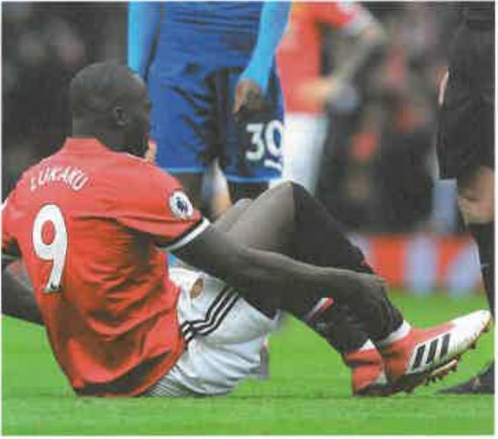

**Predictable? Manchester United's Rometu Lukaku massages his calf**

“Stopping players unnecessarily is a condition clubs want to avoid, especially for **key** players,” he says. The new forecaster halves the rate of false alarms, he says.

The Italian team that trialled the Al can't be named because it doesn't want to **give away** a competitive advantage, says Rossi. The same goes for three other top-level European football teams that have started using it, he says.

Rossi and his colleagues are now investigating whether they can increase the **accuracy** of predictions by including variables like heart rate and degree of sweating. They want to see whether they can predict the type of injury, although some will always be unpredictable, following a bad tackle, **for instance**.

Microsoft launched its own machine learning injury forecaster in June last year, which uses GPS and heart rate data, as well as players' self-reported sleep, mood and muscle soreness. It is being used by US football team Seattle Reign, Spanish football team Real Sociedad, the Seattle Seahawks NFL team and the Australian cricket team.

Their results are **mostly** confidential, but Seattle Reign says only one player got injured in the season after the team **adopted** the technology.

**Exercise: Give synonyms for the words in bold.**